# CS 255 Business Requirements Document Template

Complete this template by replacing the bracketed text with the relevant information.

This template lays out all the different sections that you need to complete for Project One. Each section has guiding questions to prompt your thinking. These questions are meant to guide your initial responses to each area. You are encouraged to go beyond these questions using what you have learned in your readings. You will need to continually reference the interview transcript as you work to make sure that you are addressing your client’s needs. There is no required length for the final document. Instead, the goal is to complete each section based on your client’s needs.

**Tip:** You should respond in a bulleted list for each section. This will make your thoughts easier to reference when you move into the design phase for Project Two. One starter bullet has been provided for you in each section, but you will need to add more.

## System Components and Design

### Purpose

*What is the purpose of this project? Who is the client and what do they want their system to be able to do?*

* The clients (Liam and Sam, 2025), Driverpass, plan to introduce new training programs that will help students pass their driving test at the DMV. To do so, DriverPass will need a system that will allow students to take online classes and practice tests, while also having the ability to schedule live road training sessions.

### System Background

*What does DriverPass want the system to do? What is the problem they want to fix? What are the different components needed for this system?*

* Liam states Driverpass aims to take advantage of the hole in the driver training market. Driverpass plans to use a system that provides online classes and practice tests to train these students. The system will also be used to schedule live road training sessions
* The system should implement role-based privileges for security. The system also requires access to data both online and offline, as well as tracking changes to records in the system. Using a web-based client over the cloud, the system needs the ability to update the provided packages and content of courses.

### Objectives and Goals

*What should this system be able to do when it is completed? What measurable tasks need to be included in the system design to achieve this?*

Users will be able to schedule live road training with an online account or by calling in and giving their information.

* Users should be allowed to choose from 3 different packages while having the option to edit or cancel their appointments. These packages should have the ability to be updated or disabled.
* The system should provide access to online classes and practice test for users that can be updated when needed.
* Driverpass should have access to data from the system both online and offline from their phone or computer.
* The system should keep records of changes to data in the system to provdie and activity report
* The system should implement role-based privileges to allow Driverpass to easily manage access.

## Requirements

### Nonfunctional Requirements

*In this section, you will detail the different nonfunctional requirements for the DriverPass system. You will need to think about the different things that the system needs to function properly.*

#### Performance Requirements

*What environments (web-based, application, etc.) does this system need to run in? How fast should the system run? How often should the system be updated?*

* A web-based client in a cloud environment should be used
* Users will constantly be interacting with the system, so load times should be quick to create a smooth experience
* The system should be updated when needed to keep up with changes to the DMV, content, and prices.

#### Platform Constraints

*What platforms (Windows, Unix, etc.) should the system run on? Does the back end require any tools, such as a database, to support this application?*

* The system needs to run on desktop platforms like Windows, Linux, and MacOS. The system also needs to support Android OS and iOS to ensure that as many users as possible can access the system.
* Mobile devices could use a browser or a dedicated web app to be more accessible.
* The cloud service provider will handle the database management and running the servers.

#### Accuracy and Precision

*How will you distinguish between different users?* *Is the input case-sensitive? When should the system inform the admin of a problem?*

* Users will have separate logins with unique emails/usernames and passwords.
* Login information will be case-sensitive.
* An admin should be informed when a user wants to reset their password.
* The system will keep records of changes in the system that the admin can access.

#### Adaptability

*Can you make changes to the user (add/remove/modify) without changing code? How will the system adapt to platform updates? What type of access does the IT admin need?*

* An admin will be able to reset user passwords and block accounts.
* Specific users will be able to change and disable offered packages.
* Specific users will be able to update the learning content.
* These changes will happen in a database which will allow all platforms to easily adapt.
* IT admin needs access to the server provided by the cloud service provider and the database.

#### Security

*What is required for the user to log in? How can you secure the connection or the data exchange between the client and the server? What should happen to the account if there is a “brute force” hacking attempt? What happens if the user forgets their password?*

* A username/email and password are required for login
* Using HTTPS protocol with two factor authentication will ensure a secure connection
* In an instance of a “brute force” attempt the admin should be notified and the account should be locked out after many failed attempts.
* Users will have access to a reset password button that will automatically send an email that will allow them to reset their password.

### Functional Requirements

*Using the information from the scenario, think about the different functions the system needs to provide. Each of your bullets should start with “The system shall . . .” For example, one functional requirement might be, “The system shall validate user credentials when logging in.”*

* The system shall validate user credentials when logging in.
* The system shall allow users to reset their password
* The system shall allow users to register accounts
* The system shall display login errors
* The system shall provide users the option to schedule on the road training sessions
* The system shall record changes in the database
* The system shall allow admins to manage account access
* The system shall allow admins to disable and change offered packages
* The system shall allow admins to change learning content
* The system shall allow users to view scheduled appointments
* The system shall allow drivers to enter notes for their session
* The system shall provide downloadable reports
* The system shall allow users to take practice tests and online classes
* The system shall allow users to select between offered packages
* The system shall use a web service via a cloud service provider to run on multiple platforms

### User Interface

*What are the needs of the interface? Who are the different users for this interface? What will each user need to be able to do through the interface? How will the user interact with the interface (mobile, browser, etc.)?*

* The users for the interface are students, drivers, a secretary and administrators.
* Students need to be able to access learning content, schedule on the road training, select desired package, view driver notes, login, reset password, register an account, take practice tests, take online classes, and view their scheduled appointment.
* Drivers need to be able to login, reset password, view scheduled appointments, and enter driver notes after a training session.
* The secretary needs to be able to register student accounts, Login, reset password, schedule training sessions, and view scheduled appointments.
* The Administrators need to have the abilities of all other users while also being able to view data, change data, download reports, update learning content, update or disable packages, manage user access, block accounts, and reset passwords for other accounts.
* The user will be able to access the system through a browser on mobile and desktop devices as well as mobile applications.

### Assumptions

*What things were not specifically addressed in your design above? What assumptions are you making in your design about the users or the technology they have?*

* Users will have access to the internet to connect to the system.
* Users will have the necessary hardware requirements.
* IT will have the necessary skills to administrate the system.
* Users will have 24/7 access to the system.

### Limitations

*Any system you build will naturally have limitations. What limitations do you see in your system design? What limitations do you have as far as resources, time, budget, or technology?*

* Users will need reliable internet connection to interact with the system.
* Adding content for the online classes and practice tests could take a lot of time.
* Possible licensing for content in online classes could come at a high cost.
* The client has 10 cars available and could be overbooked.
* The cloud service provider could also come at a high cost.
* There will be a cost to maintaining the system.

### Gantt Chart

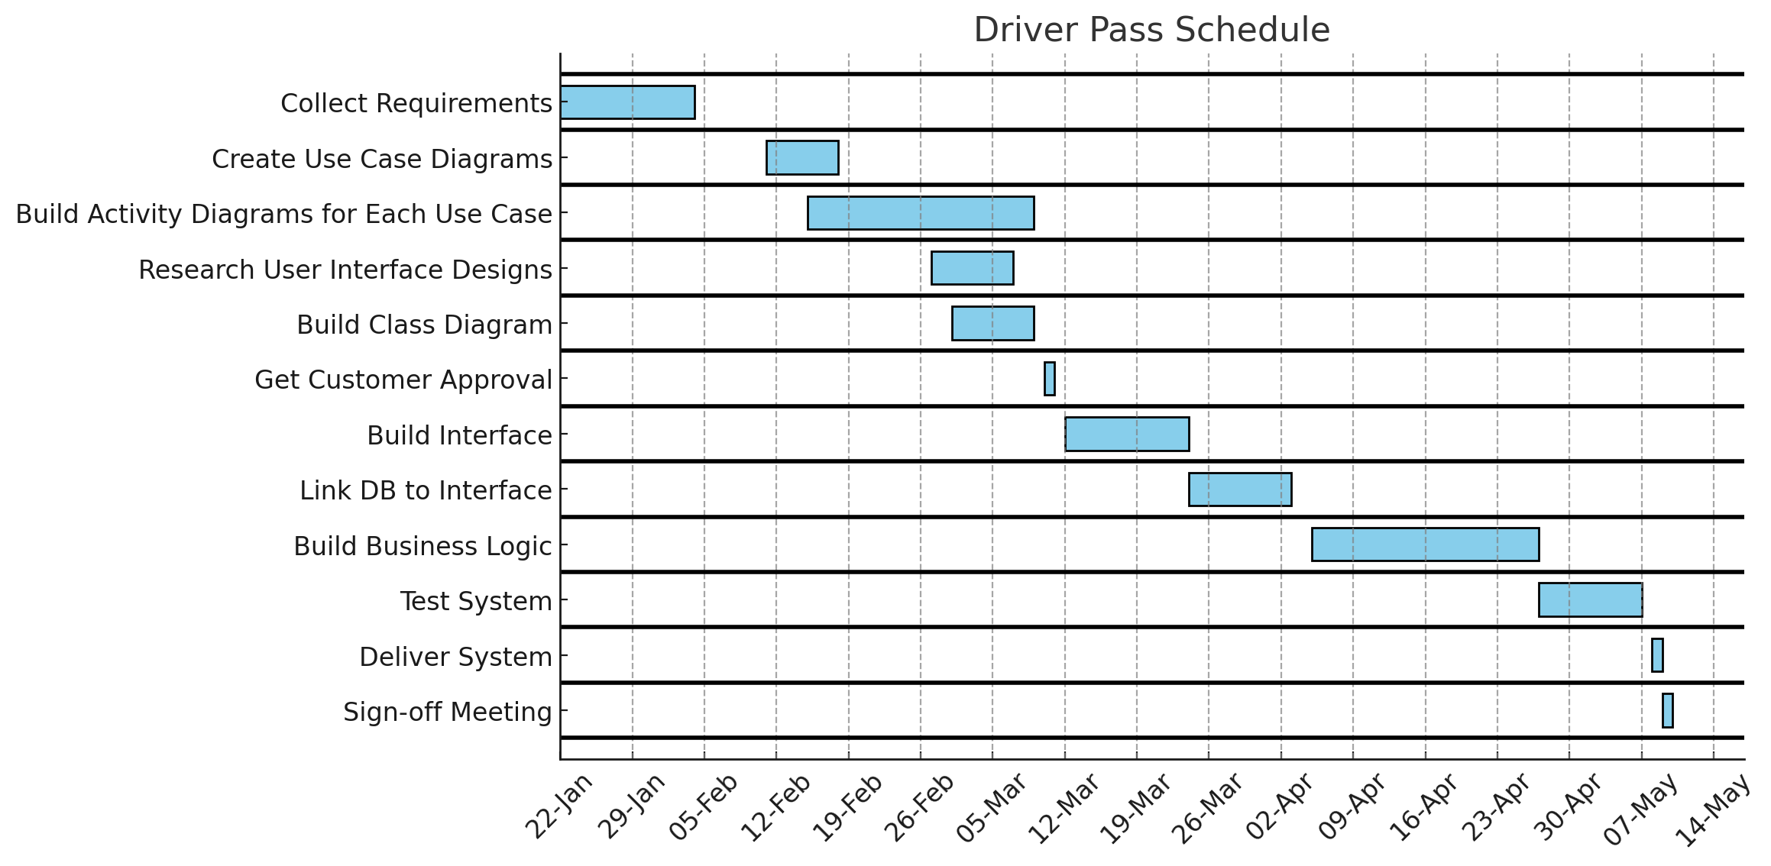

**References**

Liam, Ian, Sam, Jennifer (2025, 1/06) *CS 255 DriverPass Interview Transcript* https://learn.snhu.edu/content/enforced/1798810-CS-255-13949.202511-1/course_documents/CS%20255%20DriverPass%20Interview%20Transcript.pdf?ou=1798810